Holiday to the Cairngorms staying at the
Duke of Gordon Hotel Kingussie.
Sunday 16th May to Friday 21st May 2027 (6 days, 5 nights)

BEFORE YOU BOOK THIS HOLIDAY TO THE CAIRNGORMS, PLEASE READ VERY CAREFULLY THE INFORMATION CONTAINED IN THIS INTRODUCTORY SECTION AND CONSIDER THE INFORMATION PROVIDED ABOUT THE HOTEL.
- The Cairngorms and in particular Kingussie are almost 500 miles from Ely, the journey there and back will therefore take a whole day.
- To arrive in time to enjoy our evening meal, the first pick up will be at 6am.
- Attractions in Scotland can also be a fair distance away, especially the spectacular Isle of Skye, which will be one of our outings.
- Travellers will need to wear the appropriate footwear, as the terrain can be uneven.
- Finding a hotel in such a remote area, which can provide us with 20 single rooms, and which doesn’t cost the earth, is not an easy task.

Hotel Information

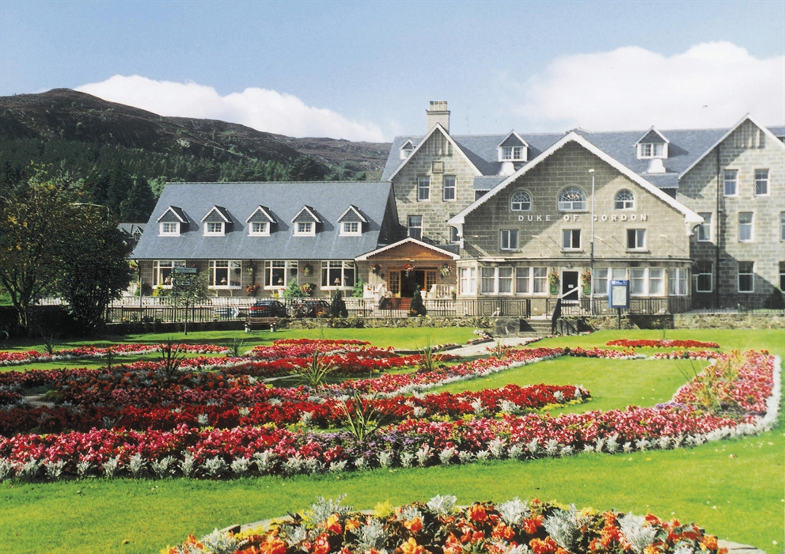

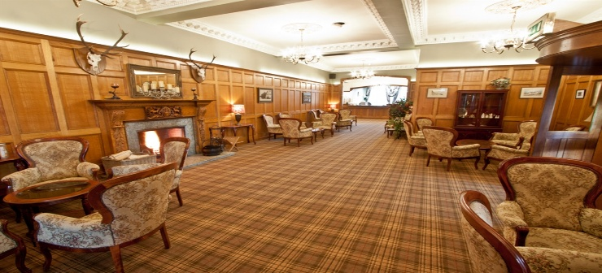

The hotel will provide:

- Porterage on arrival & departure (Coach - Room - Coach)
- Full Cooked Scottish Buffet Breakfast each morning
- 4 course dinner each evening with tea/coffee after dinner
- A “Scottish” evening
- A lounge bar which boasts a collection of over 50 different malt Whiskies from all over Scotland.
- Free Wi-fi

Please note lunch is not included on any day.

Sunday: Travel to the Duke of Gordon Hotel, Kingussie stopping at the Moffat Woollen Mills near the Borders to arrive at our hotel in time for our evening meal.
Excursions: The days on which excursions are planned may be subject to change.

- Monday: Return journey on the Strathspey railway with free time in Aviemore and a visit to the Highland Folk Museum on the way back.
- Tuesday: Travel to the Isle of Skye in the Inner Hebrides, trip on a glass bottomed boat to observe the sea life. Free time on the Island. Return to Hotel
- Wednesday: A totally free day.
- You could stay local and explore Kingussie or take a peaceful walk over to the local historic site of Ruthven Barracks.
- Cross the road to the Kingussie station and take a train south to Pitlochry, Stirling, Linlithgow or Edinburgh
- Or take a train north to Inverness and then a bus to Culloden
- It may be possible to arrange a visit to the Wildlife park. (Admission charge will be payable)
Remember English bus passes are not valid on Scotland’s buses.
- Thursday: Visit to Blair Atholl Castle to include time for lunch and an afternoon visit to Pitlochry, where it may be possible to taste either a range of whisky or local gins in the stores.

Friday: Travel home to Ely via Gretna, which will be our lunch stop.

Viability: We need at least 40 members booked to travel to make this holiday viable.

Cost: The costs of this holiday is £599 per person. The deposit of £100 can only be accepted in the form of a cheque made payable to Cairngorm Travel.

Single Supplements
Twin / Double for sole occupancy: £100 per person.
Please note that anyone wishing to go on the holiday needs to be a member of Ely & District U3A at the time of travel.

Outings team contacts for this holiday:
Susan Bluck 07860725074 – susanbluck2@gmail.com
Heather Carruth 07950984790 - heathercarruth83@gmail.com

